**A**

**PROJECT REPORT**

**ON**

**ONLINE EXAM PORTAL**

Submitted in partial fulfillment for the award of

Post Graduate Diploma in Advance Computing

**(PG-DAC) from**

**INFOWAY TECHNOLOGY**

**Authorized Training Centre**

**Under the Guidance of**

**Prof.Saleel Bagde**

**BY**

Omkar H. Jadhav (240343120049)

Omkar K.Khadke (240343120050)

Priya J.Wagh (240343120064)

Shruti S.Narkhede (240343120081)

**CERTIFICATE**

This is to certify that the project report entitled **Online Exam Portal** is a bonafide work carried out by Infoway Technology (and submitted in partial fulfilment of the requirement for the C-DAC ACTS, DAC course in Infoway Technology in the batch of March 2024.

Course Coordinator External Examiner

**ACKNOWLEDGEMENT**

This project **Online Exam Portal** was a great learning experience for us and we are submitting this work to Advanced Computing Training School (CDAC).

We are very glad to mention the **Prof. Saleel Bagde** for his valuable guidance to work on this project. His guidance and support helped us to overcome various obstacles and intricacies during the course of project work.

Our most heart full thanks goes to ***Mrs. Ulka Joshi* (Director ,Infoway)**who gave all the required support and kind coordination to provide all the necessities like required hardware , internet facility and extra lab hours to complete the project and throughout the course up to the last day here in C-DAC ACTS, Pune.

**TABLE OF CONTENTS**

1. Introduction
2. Software Requirement and specification
3. Tools and technologies used
4. Project Flow Diagram
5. ER Diagram
6. Advantages
7. Screenshots
8. Future Scope
9. Conclusion
10. References

### 1. Introduction



The Exam Portal web application is an online test simulator to hold online examination test in a decisive and skilled manner and thus avoiding wastage of time for manually examining the test paper. The major objective of this web based online examination system is to competently evaluate the student/candidate thoroughly through an automated system that not only saves a lot of time but also gives fast, improved, and accurate results.

It allows the students/candidate appearing for the exam to give the test/papers according to their convenience from any location by simply using internet and time over the manual/traditional pen and paper format. The online examination system provides the student/candidate with a quick and easy way to show up for the test/examination.

It also imparts and produces results of the examination immediately after the examination with 100% accuracy and security. Student can appear for the exam only with their valid credentials such as valid username and valid password. This examination consists of multiple-choice questions and appropriate number of options. This system provides time limit to each user. The candidate can verify their results immediately after the completion of the exam.

### 2. Software/Hardware Requirement



**SOFTWARE REQUIREMENTS:**

Backend Frameworks: Spring Boot & Java

Front End Frameworks: HTML5, CSS3, JavaScript & ReactJS

Runtime Environment: Windows System

Database Tool: MySQL

IDE: VS Code & Eclipse

**HARDWARE REQUIREMENTS:**

PROCESSOR: Intel core i3 or Above

RAM: 8 GB or above

HDD: 2 GB or more (Free Space)

OS: Windows 8 or higher

Screen: VGA Monitor or Laptop Screen

Mouse: Standard Mouse

Keyboard: Standard Keyboard (QWERTY)

### 3. Tools and technologies used



* SpringBoot
* MYSQL
* Git
* Spring Security
* React JS
* HTML and CSS
* Axios

1. **Spring Boot**: Utilized to develop the backend of the application, providing a robust framework for building Java-based web applications with ease.
2. **MySQL**: Chosen as the relational database management system to store book data on cloud , including user detail ,seller detail, book information and admin details.
3. **Axios**: In the context of a web application like Book Charm, Axios is likely used as a client-side HTTP library. Axios simplifies the process of making asynchronous HTTP requests from the frontend (React.js) to the backend (Node.js/Express.js). It is instrumental in fetching data from the server, handling API calls, and facilitating smooth communication between the frontend and backend components, ensuring efficient data retrieval and seamless user interactions in the e-commerce application
4. **React**: Employed to build the frontend of the application, offering a component-based architecture for creating dynamic and interactive user interfaces.
5. **CSS**: Used for styling the frontend components with utility-first CSS classes, allowing for rapid prototyping and customization of the user interface.
6. **Git**: Implemented as a version control system to track changes in the source code, enabling collaboration among developers, and facilitating code management and deployment workflows.



### 5.Project E-R(Entity relationship) Diagram



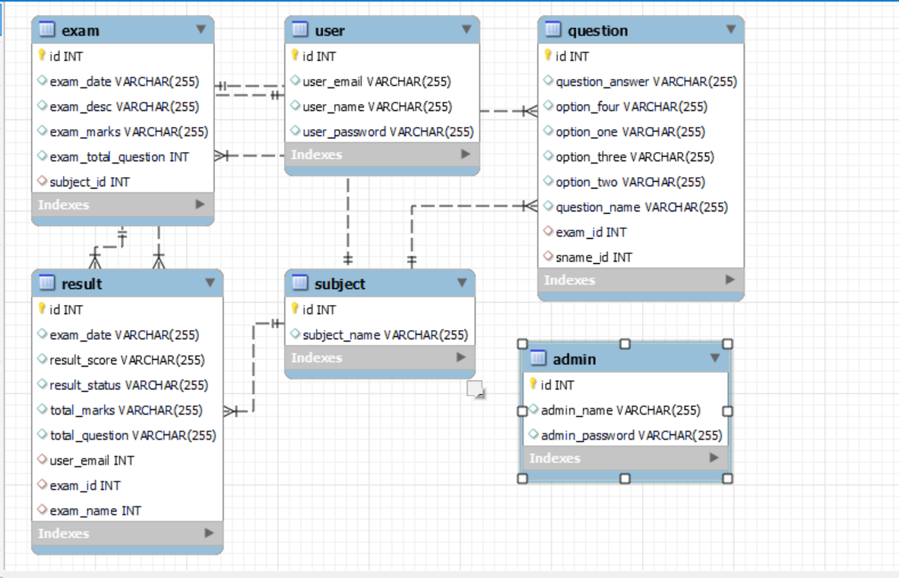

#### 6. Advantages



* + More secure, less cheating
  + It saves time and cost.
  + There is no need to arrange an examination room and no need to print exam papers.
  + Assigning marks and levels: The marking scheme needs to be properly defined in an online test for automatic result generation in the later stage
  + Environment friendly processes, or environmental-friendly processes provide easy access to the exam for students,
  + Without paper versions, there is no more need to keep track of every individual test.

#### 7. Screenshots



**Fig 1] Home Page**

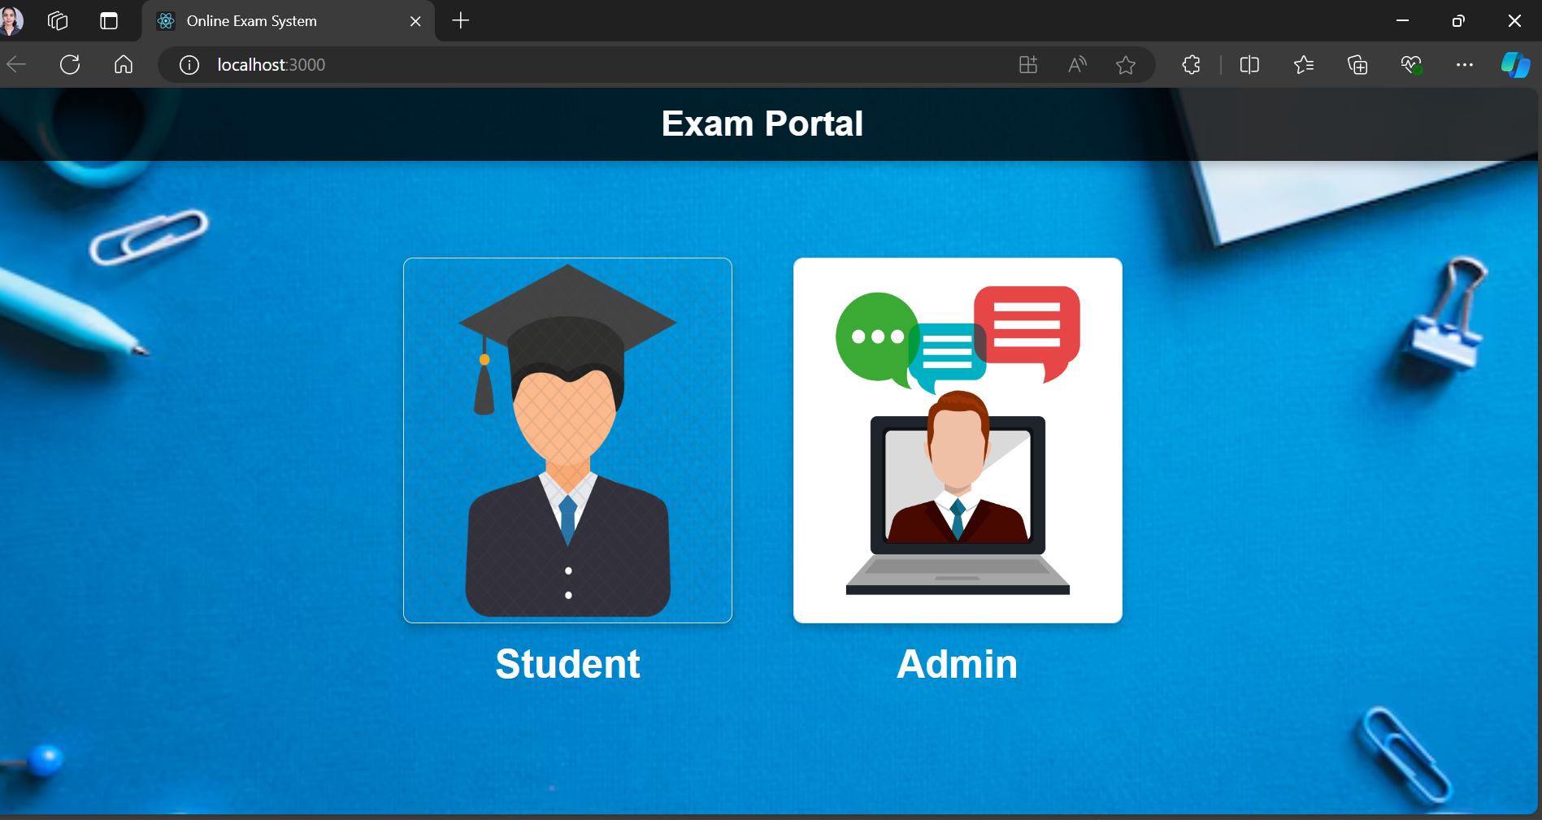

**Fig 2] Student SignUp Page**

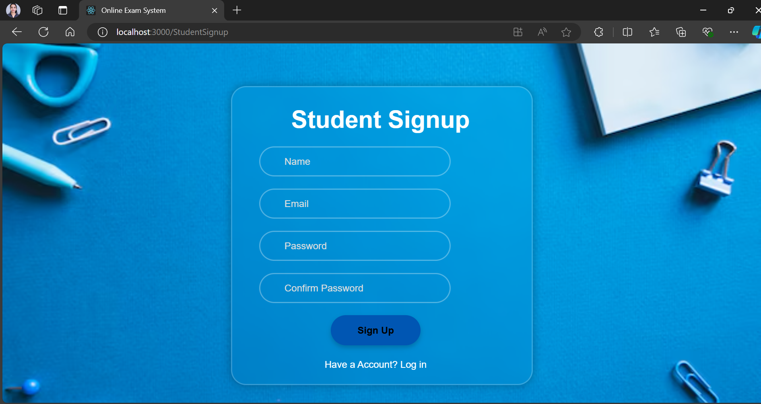

##### Fig 3] Student Login Page

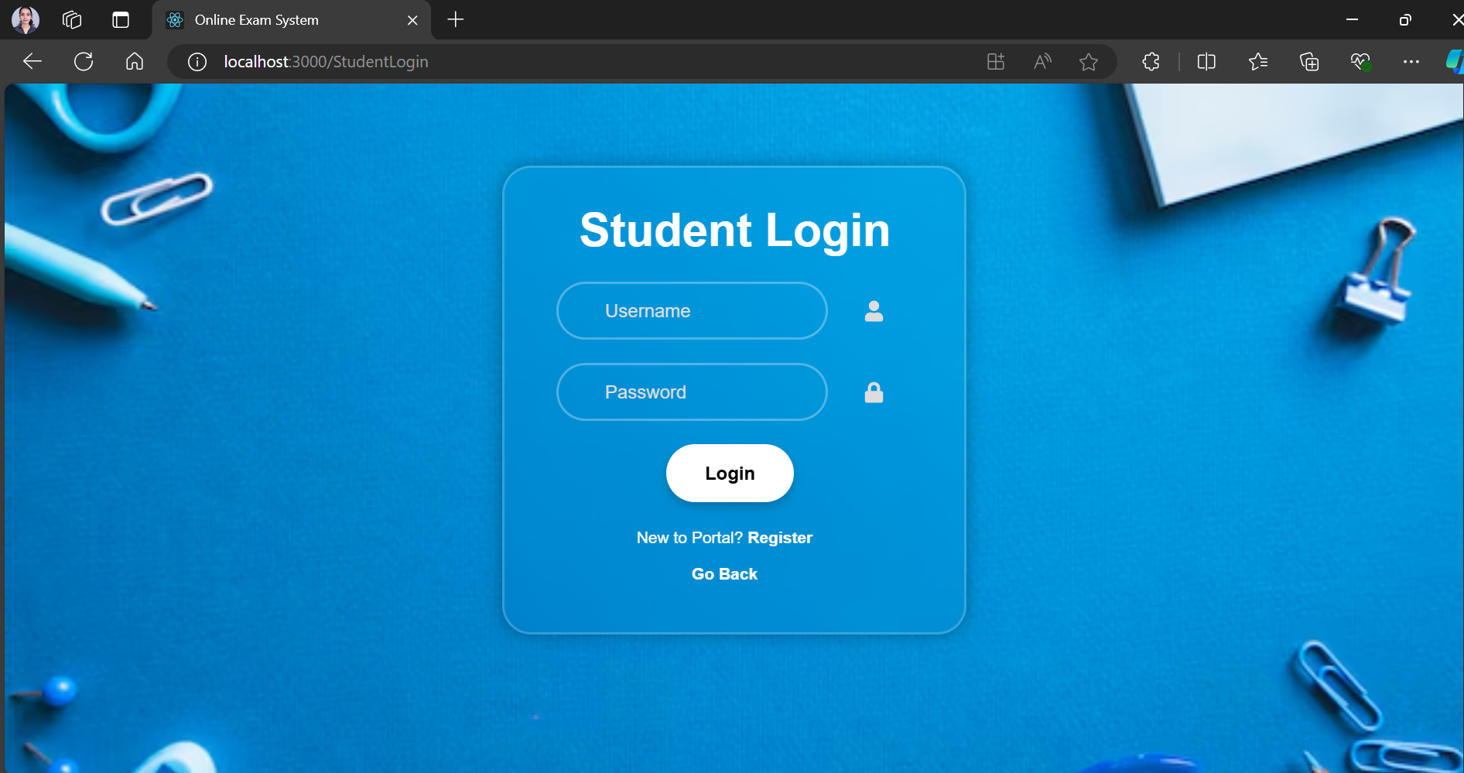

**Fig 4] Student Dashboard**

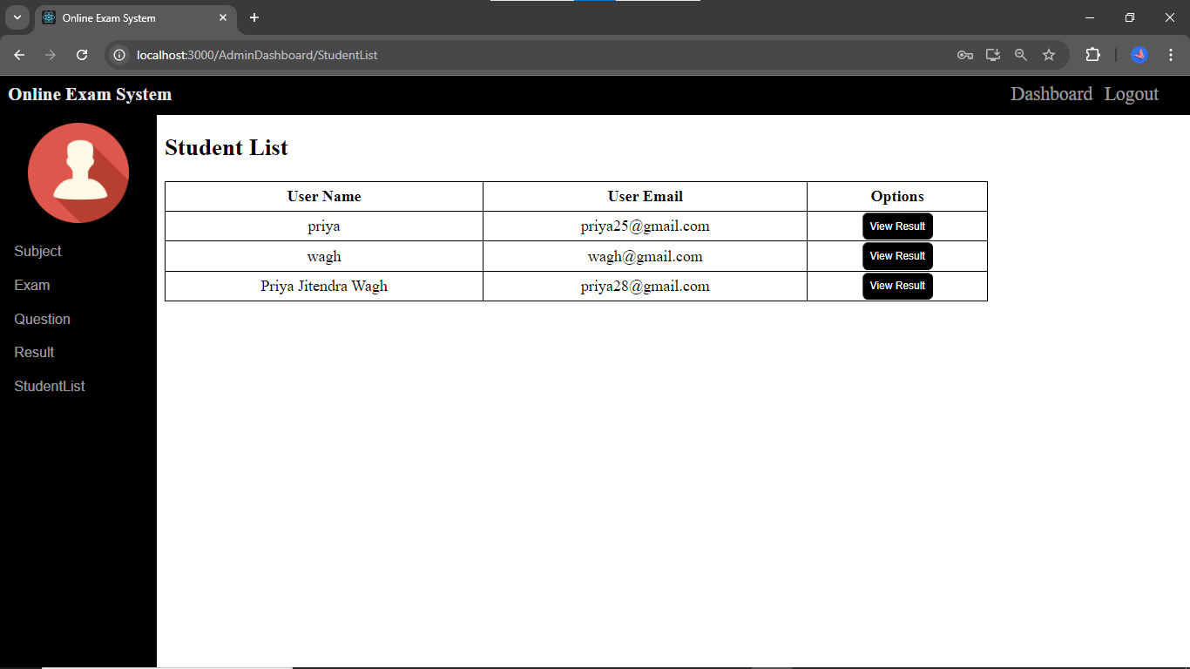

##### Fig 5] Admin Login

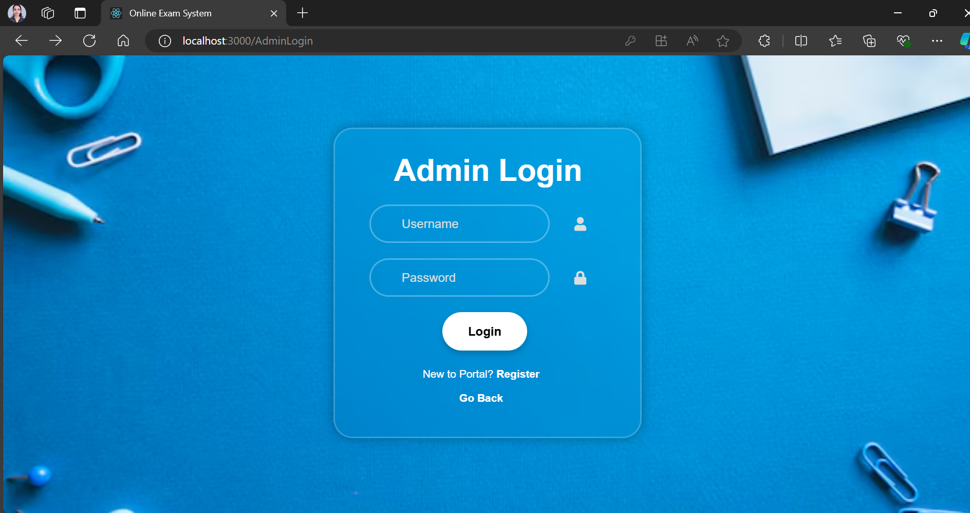

**Fig 6] Admin Dashboard**

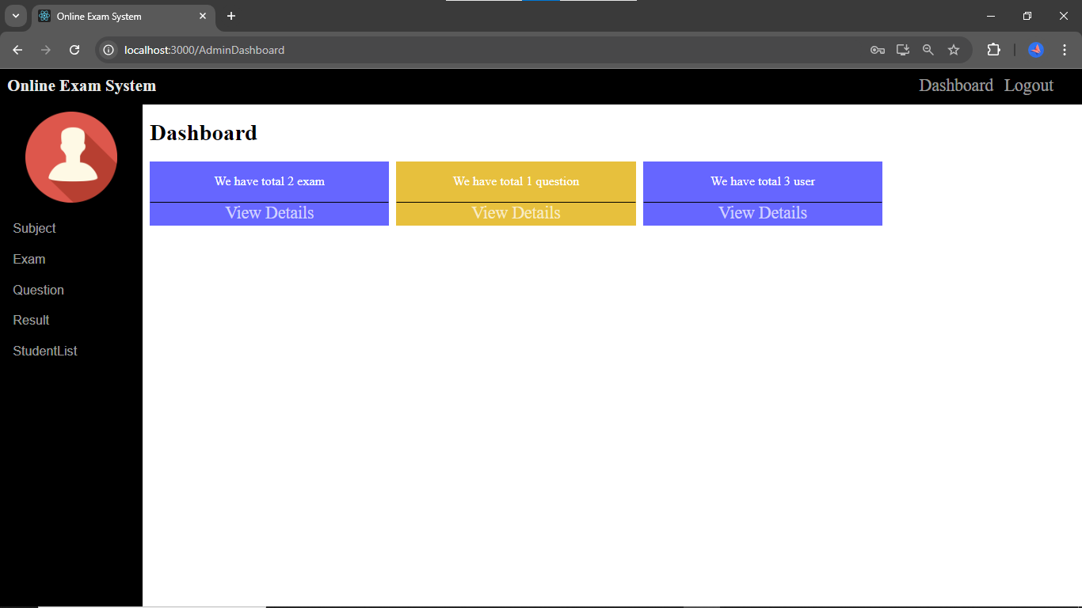

**Fig 7] Exam Page Dashboard**

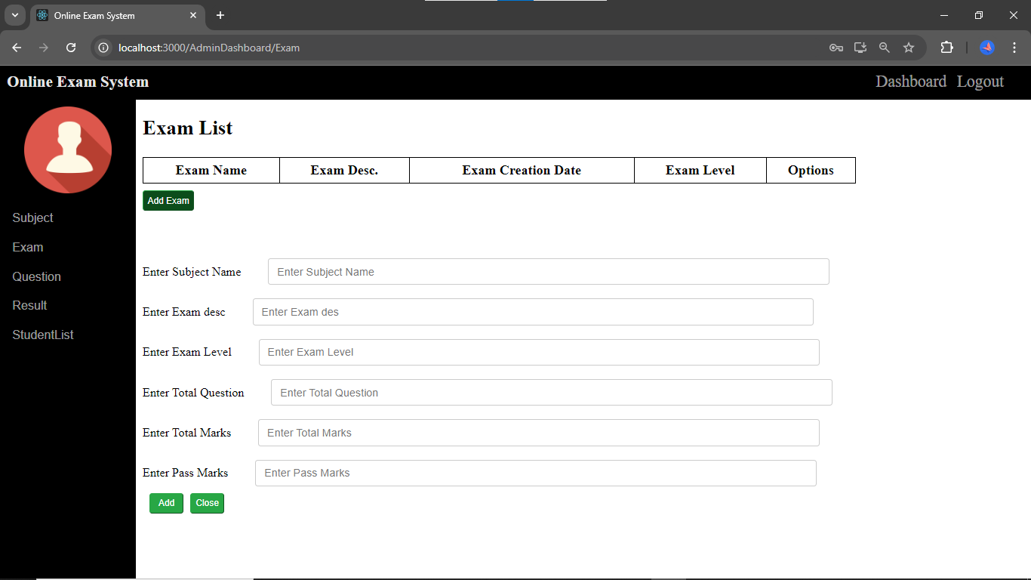

**Fig 8] Subject Page Dashboard**

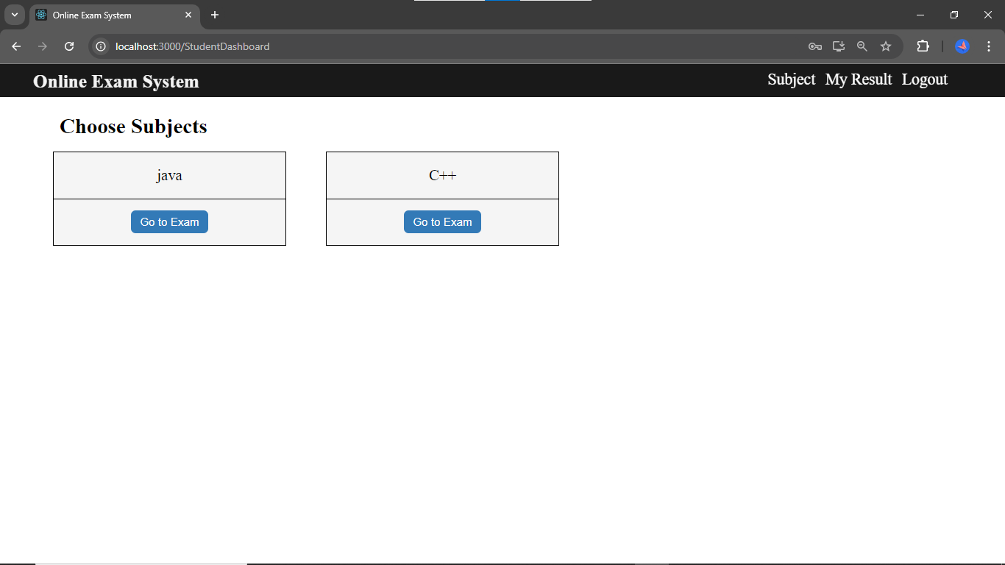

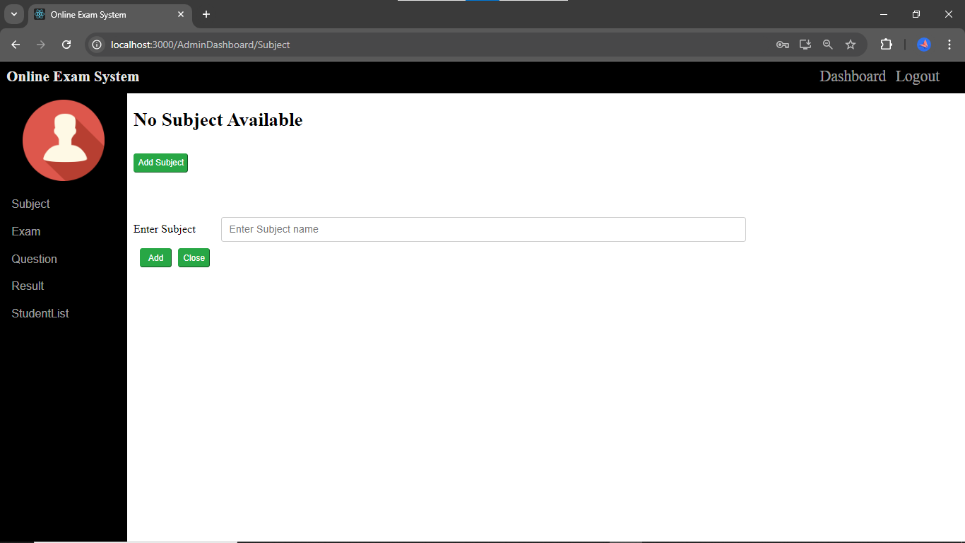

**Fig 9] Question Page Dashboard**

##### 

**Fig 9] Result Page Dashboard**

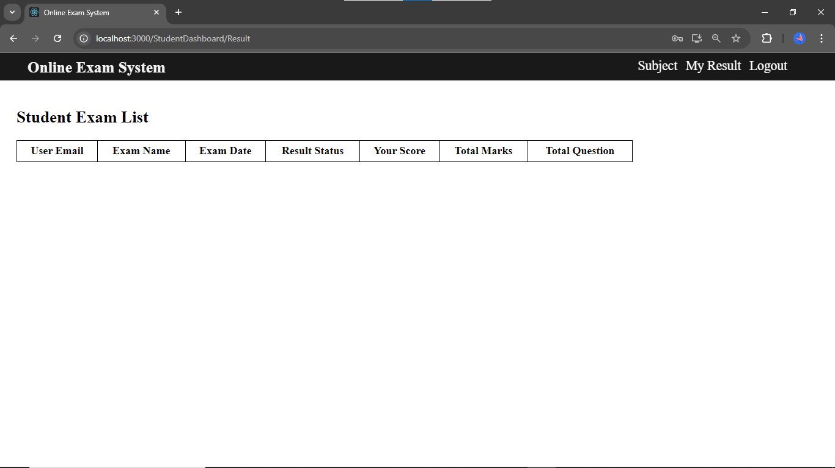

**Use Case Diagram**

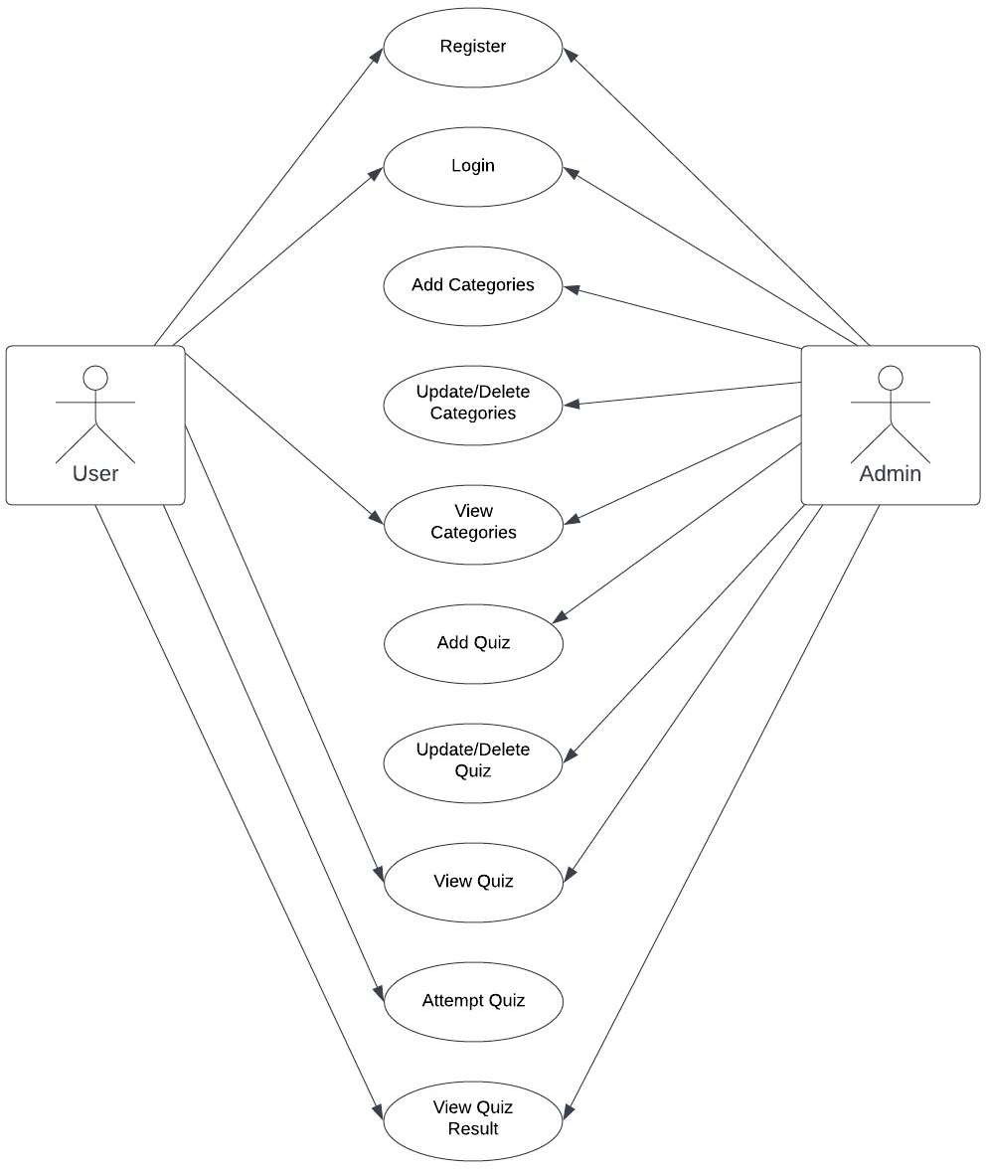

**8. FUTURE SCOPE:**

Steady improvement in innovation has prompted a fast development of the evaluation business. Large numbers of the training organizations and colleges are building up their interest in web tests through online assessment programming for their understudies rather than pen and paper- based test. It demonstrates that online assessment software is the future of evaluation techniques. We have made an online assessment framework, and we will be dealing with it in the future and will make a great deal of improvement like-

1. Adding the screen-sharing & live camera feature to enhance the security and prevent any kind of suspicious activities.

ii. Voice acknowledgment.

Fingerprint validation,

iv. Facial recognition acknowledgment.

##### 9. Conclusion



This paper introduces a secure system for internet-based exam invigilation, whose work maintains academic integrity in e-learning. This web-based system is convenient and user- friendly for utilizing, from the candidate's perspective, as it only needs one laptop or smartphone. The key concept is to minimize the amount of traditional, pen-paper form of cxamination and convert all forms of documentation to digital form. It was observed that the data/information required can be obtained with much simplicity, accuracy and in a secure manner, through the computerized system. The user with limited knowledge about the computer may also access the system with ease. The system abo yields detailed result as required.

##### 10. References



1. https://spring.io/projects/spring-boot
2. https://spring.io/projects/spring-data-jpa
3. https://restfulapi.net/
4. [https://www.mysql.com/](http://www.mysql.com/)
5. https://spring.io/projects/spring-web
6. <https://reactjs.org/>
7. <https://nodejs.org/>